75 subjects in each group results (50 with a glitched version of final feedback and 25 normal sub in each group)

The glitch was that in final tests, some items’ feedback was partially mistaken (first sentence tell them The word you typed WAS NOT STUDIED! , but second sentence says “The word you typed WAS FROM LIST X”. These two feedback appear together in a line for some items as a glitch, causing a little bit confusion in final test, probably. Though the data visualization itself didn’t show much difference, so I the below is a draw for all the data.

Design: first two letter cued recall of words: 8 lists of 20 pictures. Every other 2 lists are in pairs.
Initial test: in each list: 10 unique and 10 repeat items. 3 unique and 5 repeat randomly selected to be tested.
Final test:.5 groups (forward, backward, random, forward random, and backward random). Final test tested everything from initial test, and participants are asked to only fill in one blank.

Before each testing list, participants are informed the list number such as “list 1”. And during each test, participants see prompt asking them to fill in, e.g., word from list 1, even though another word with same cue could from list 2 (for repeat condition only). Feedback is “The list was from list x” vs. “The word you typed was incorrect”. Participants could also type “none”, and no feedback would be given that way.

No time restriction was given for the test, and RT are recorded for first key press and also for time when they finished typing and press enter. The following RT results are first key press time.

3 plots:
Figure 1 a,b,c :Accuracy; RT; RT for first key press
Figure 2 a,b,c: conditional accuracy, RT
Figure 3: Protrusion in initial test

- Accuracy
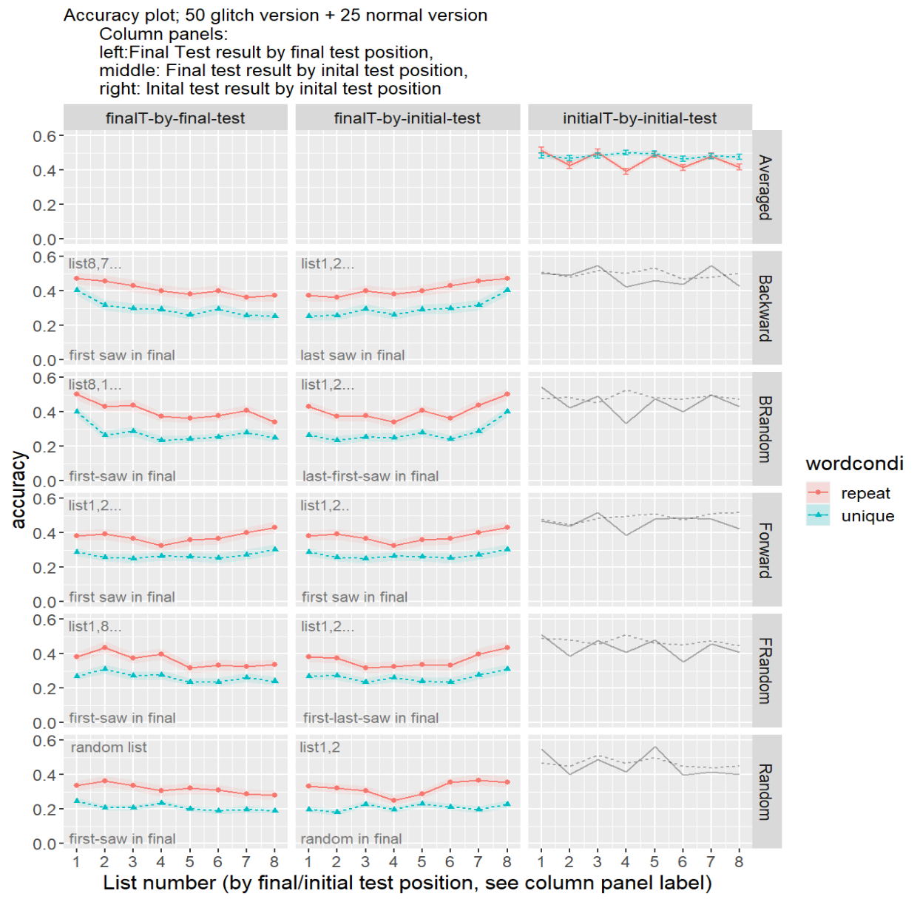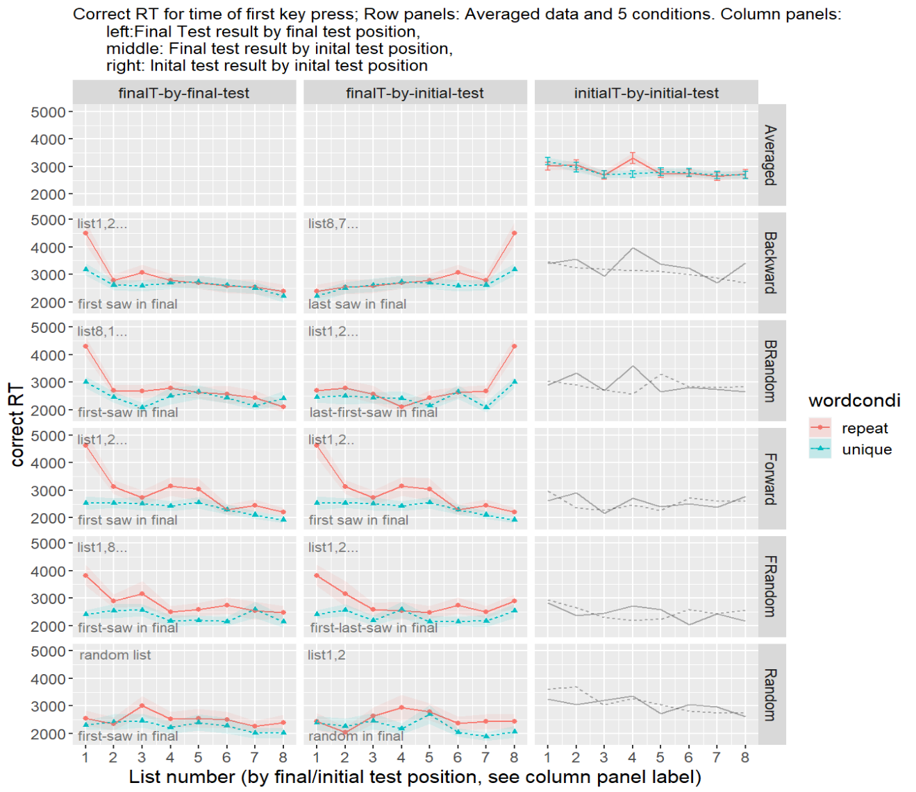
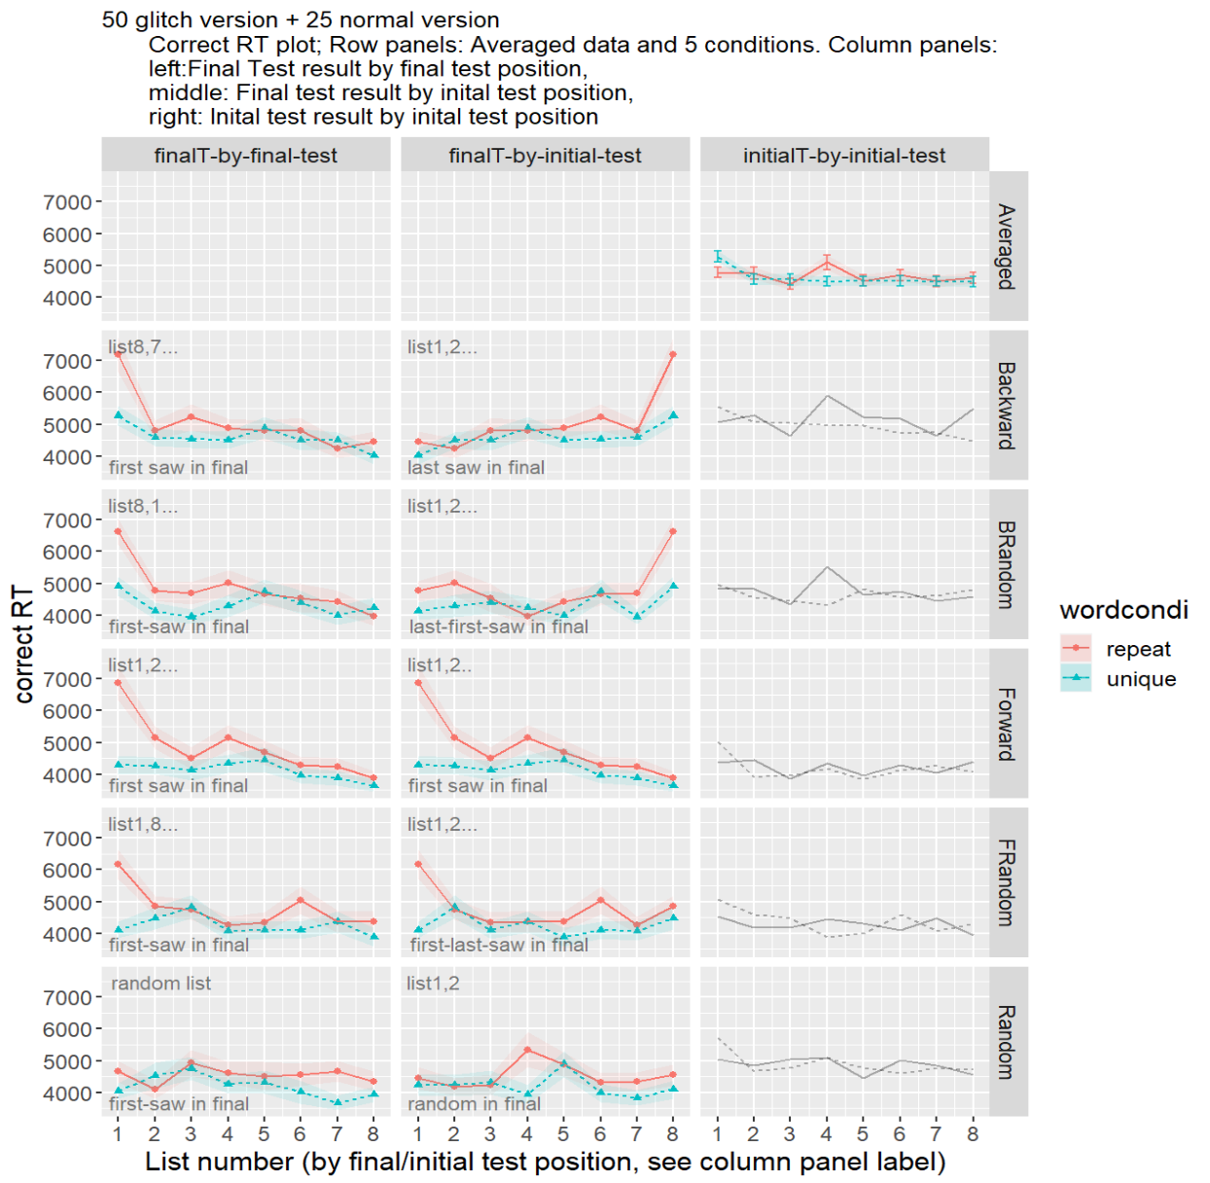

- Conditioned accuracy and rt
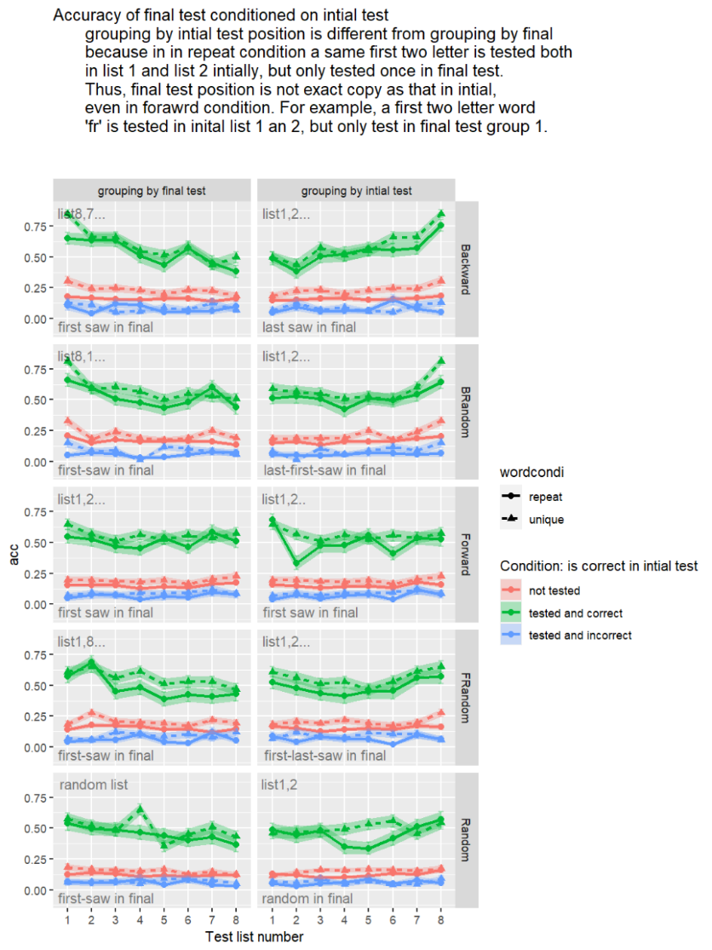
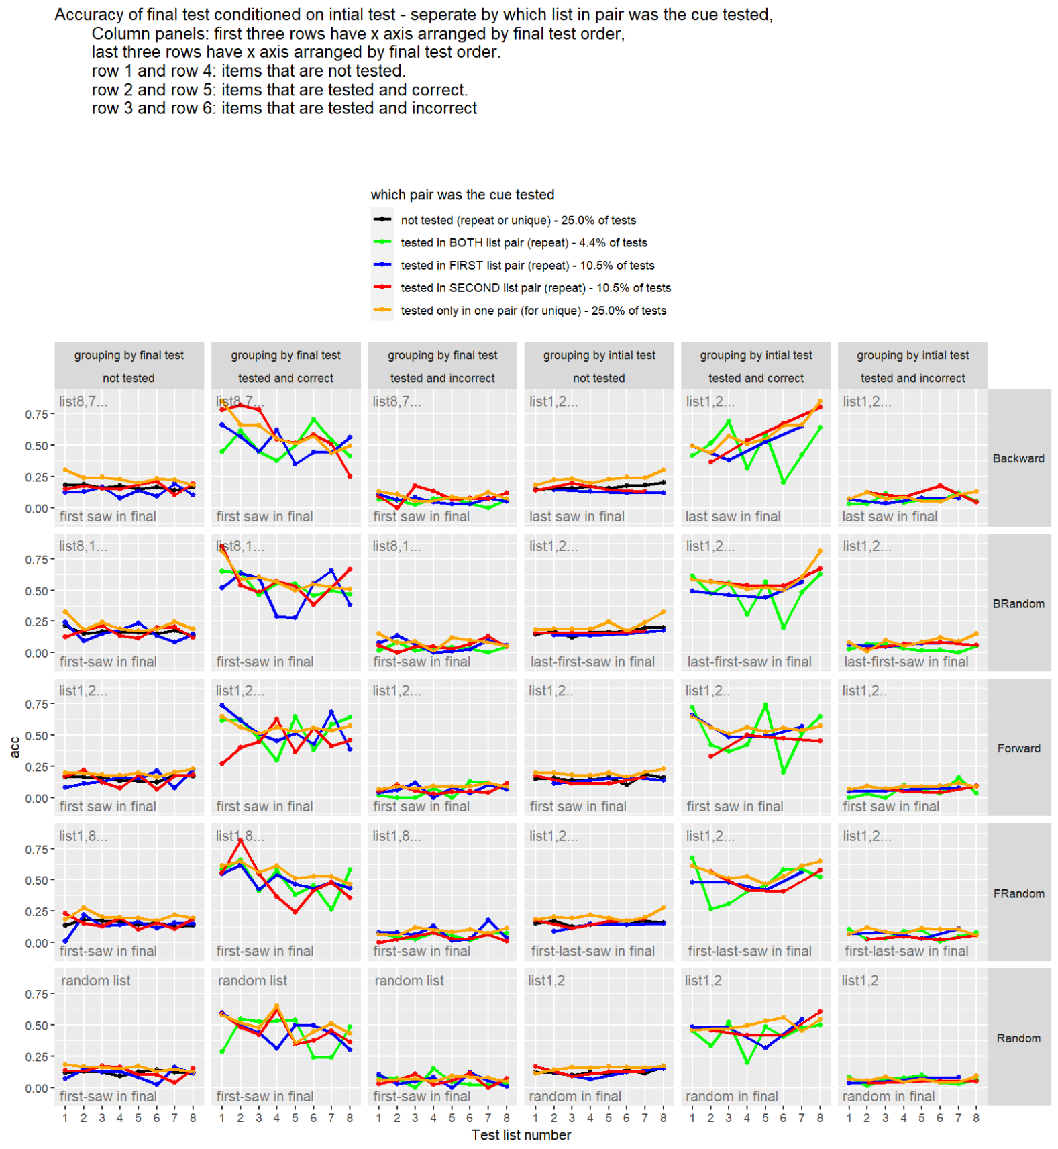

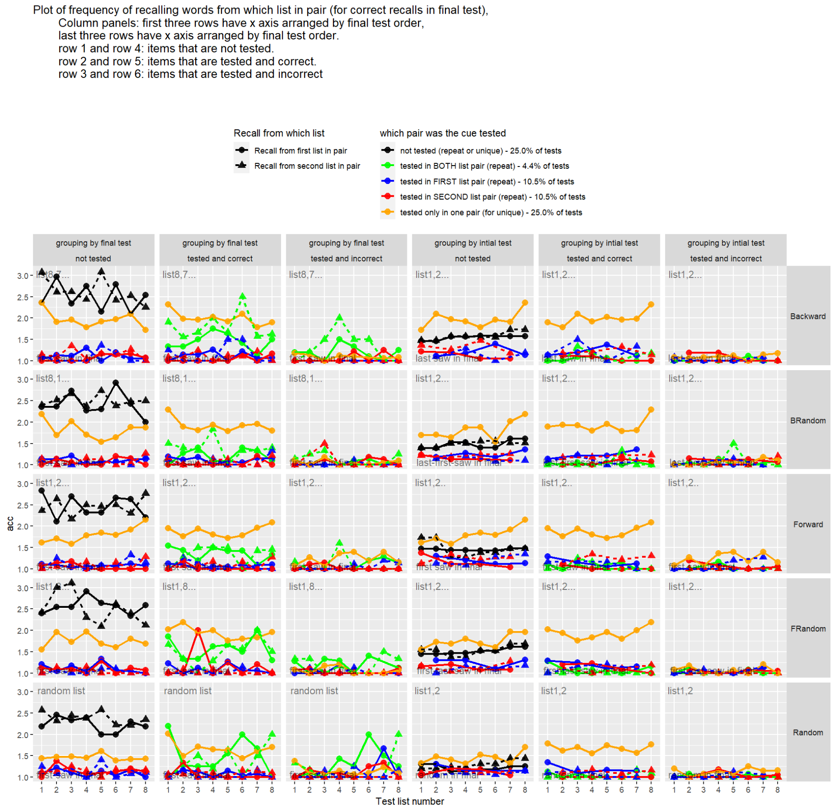

Note: Final test correction rate is low so correct RT is based on a small amount of data
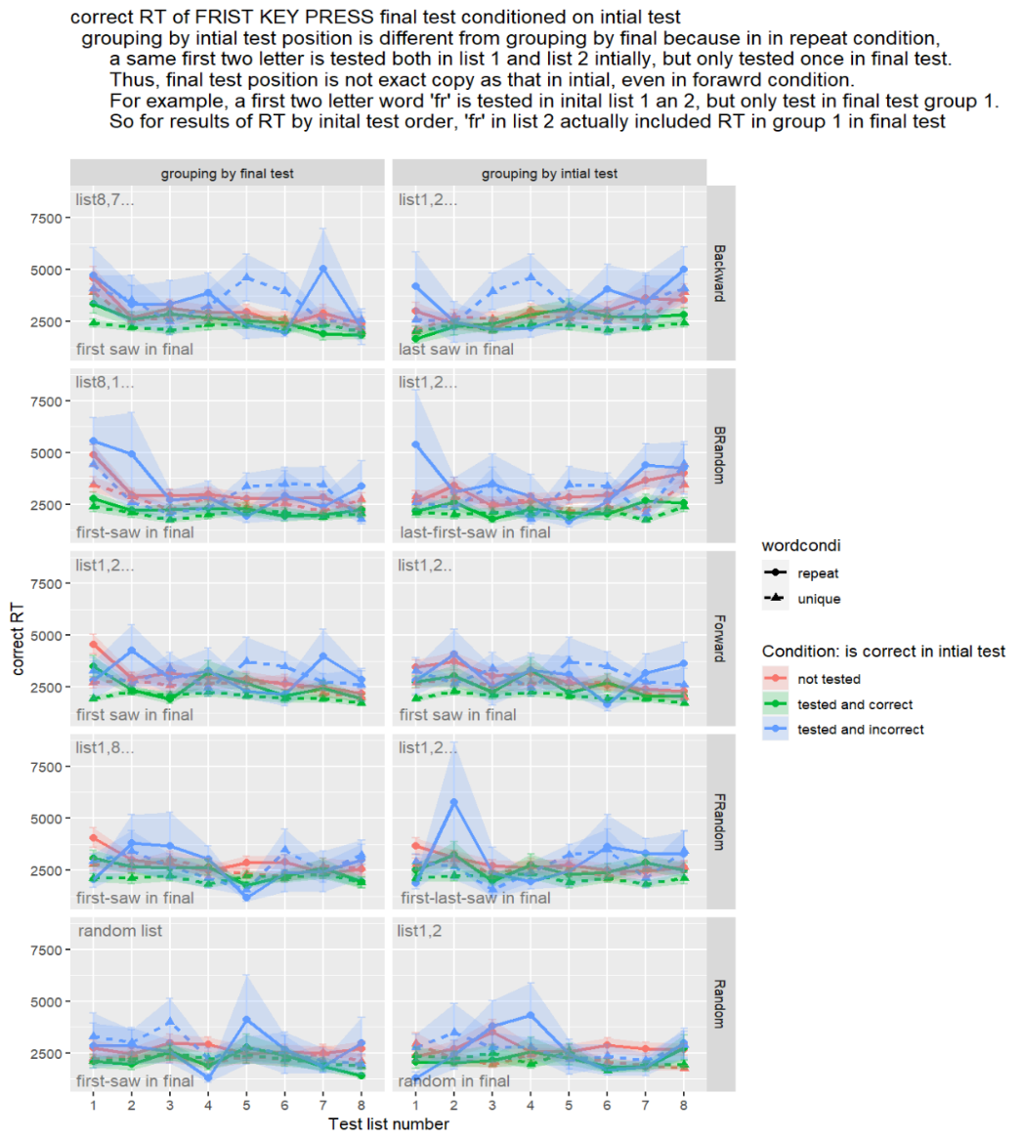
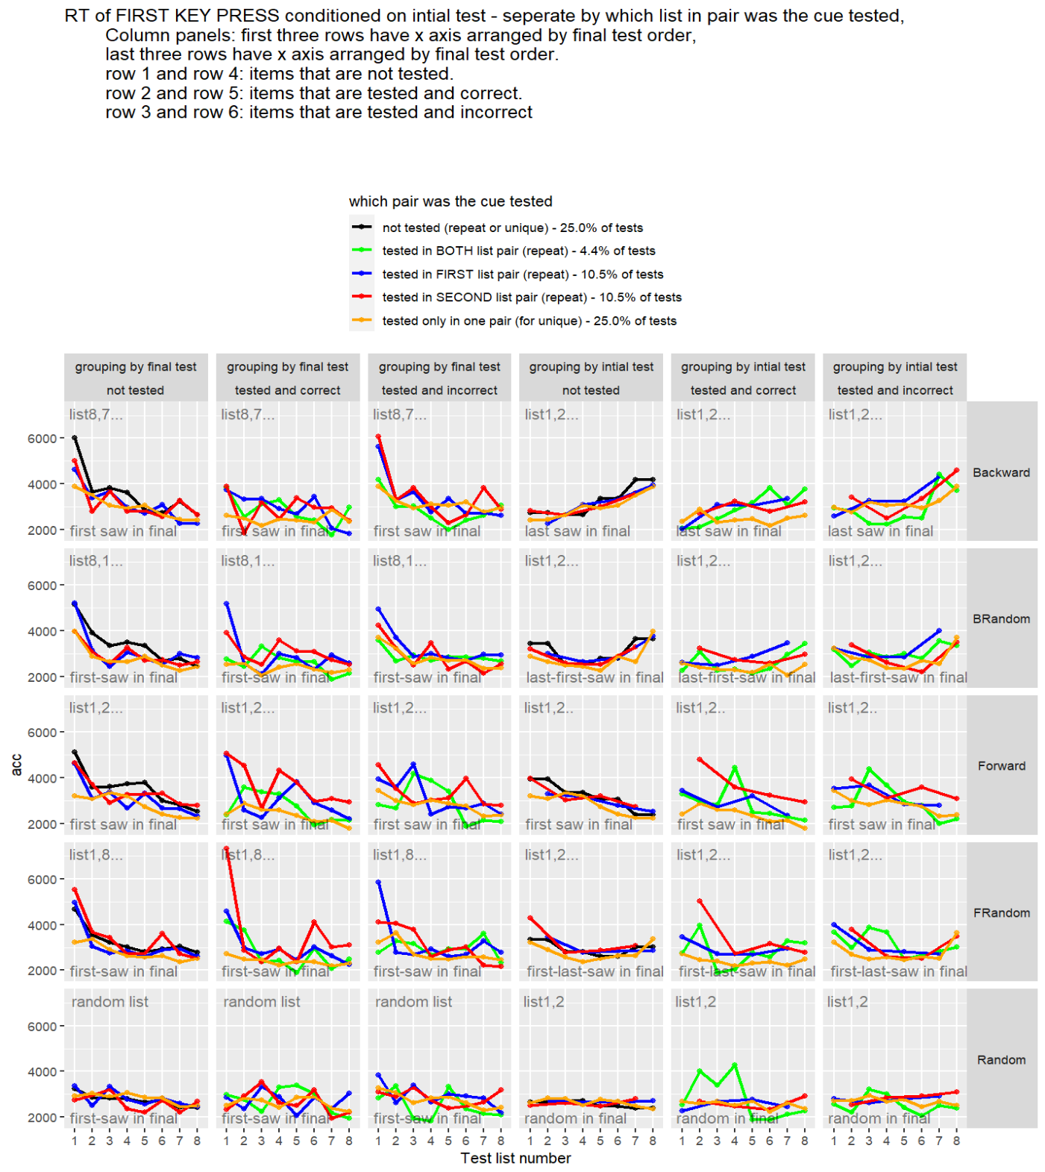

- Protrusion (recall of word from prior list in initial list). Frequency of item tested twice is around 9% of all tests
